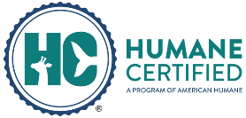
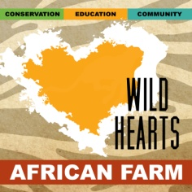
Wild Hearts African Farm & Petting Zoo
APPLICATION FOR
INTERNSHIP PROGRAM
8079 Salem Road, Lewisburg, Ohio 45338
937-416-5520 www.WildHeartsAfricanFarm.org 501c3 Non-profit # 46-5750211

This Wild Hearts Internship Position is a hands-on, un-paid, voluntary agritourism and zoology learning opportunity allowing those interested in animal care careers to gain experience working with animals in a zoo and farm setting.
REQUIREMENTS: This program lasts for a minimum of 300 hours, and includes at least three shifts per week for a minimum of 12 weeks. Many interns choose to complete more than 300 hours for college requirements or extra experience. Work days typically start at 8 or 9am but may be adjusted for program needs. Additional days and times may be added to include Onsite Tours and offsite Mobile Teaching Zoo Programs offered during afternoons, weekends, holidays and evenings. Applicant must commit to set schedule and be on-time. This voluntary position requires working inside and outside in all weather conditions, with a variety of animals. strenuous lifting, cleaning, shoveling, following instructions and mental alertness. Applicants must be at least 18-years-old. You must possess a valid driver’s license and have a vehicle as public transportation is not available at our location.
Instructions: E-mail this complete application and attachments in ONE email to amanda@wildheartsafricanfarm.org.
Please label your file names with your last name.
Attach a cover letter, resume, and two letters of recommendation OR references we may contact.
Applications are accepted year-round!

Contact Information
Name:
Street Address | City: State: Zip:
Cell Phone:
E-Mail Address:
Driver’s License #
College & Major | Graduation Date:
Current Employer Name Address & Phone:
Availability Dates  (12 Week Minimum) : | Start Date: Through:

Availability Schedule - Please mark at least 5 days you are available even if you can only commit to 3 days per week.
We try to accommodate class schedules. Favor will be given to applicants with the most schedule flexibility.
 | Sunday | Monday | Tuesday | Wednesday | Thursday | Friday | Saturday
We typically start at
8-9am and you will work a 6+ hour shift.

Special Skills or Qualifications

Summarize special skills and qualifications you have acquired from employment, previous volunteer work, or through other activities, including hobbies or sports.

Please summarize your previous zoological or related animal husbandry experience

Tell us why you want to be a "Wild Hearts Intern"

If chosen, tell us how you plan to COMMIT yourself to get the most from this opportunity.

What is your favorite animal, why and how do you hope to impact conservation for that species?

Person to notify in Case of Emergency
Name
Street Address
City ST ZIP Code
Home Phone
Work Phone
E-Mail Address

Agreement and Signature

By submitting this application, I affirm that the facts set forth in it are true and complete. I understand that if I am accepted as an intern, any false statements, omissions, or other misrepresentations made by me on this application may result in my immediate dismissal.

HOUSING & TRANSPORTATION: (Initial) _____ I understand that Wild Hearts does not provide housing, transportation or fuel stipends, and that I am responsible for researching and acquiring housing and transportation. By applying for this internship I acknowledge that have sufficient resources and time to commit to the position requirements.

____ (Initial) I have received, read, understood, agreed to and will comply with the Volunteer/Extern/Intern Waiver and Volunteer Guidelines and Requirements on the following two pages. I will purchase and wear a staff shirt ($20) to all programs. I understand that vacation requests and days off may not be accommodated during this short internship duration. Unexcused absences and tardiness may be grounds for termination. I understand this is an un-paid internship and will not receive any compensation.
____ (Initial) Resume, cover letter and two letters of recommendation or references are included.
Name (printed)
Birthdate (Must be 18+)
Signature & Date

Our Policy

It is the policy of this organization to provide equal opportunities without regard to race, color, religion, national origin, gender, sexual preference, age, or disability.
Thank you for completing this application form and for your interest in volunteering or interning with us.

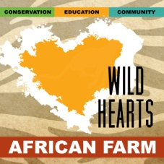
Waiver
Wild Hearts African Farm & Petting Zoo

This Release and Waiver of Liability is executed by the Volunteer/Extern/Intern ("Volunteer"), parent, or guardian, in favor of Wild Hearts Zoological Park, LLC and Wild Hearts Zoological Society a nonprofit corporation, DBA Wild Hearts Zoo and Wild Hearts Zoo African Farm and Petting Zoo ("Zoo"), its directors, board members, advisors, investors, employees, and agents. The Volunteer desires to participate in the Zoo’s programs and activities, and understands their participation may include a variety of activities required in operating the Zoo that imposes inherent risks and dangers.
Ohio Revised Code 901.80 "WARNING: Under Ohio law, there is no liability for an injury to or death of a participant in an agritourism activity conducted at this agritourism location if that injury or death results from the inherent risks of that agritourism activity. Inherent risks of agritourism activities include, but are not limited to, the risk of injury inherent to land, equipment, and animals as well as the potential for you as a participant to act in a negligent manner that may contribute to your injury or death. You are assuming the risk of participating in this agritourism activity.”
The Volunteer does hereby freely, voluntarily, and without duress execute this Release under the following terms:
1. Waiver and Release. The Volunteer does hereby release and forever discharge and hold harmless the Zoo and its successors and assigns from any and all liability, claims and demands of whatever kind or nature, either in law or in equity, which arise or may here after arise from Volunteer participation in any Zoo programs. The Volunteer does hereby release and forever discharge the Zoo of any legal fees related to the Volunteer's participation at the Zoo and its corresponding activities on the Zoo's facilities or elsewhere.
2. Protocol Compliance. The Volunteer hereby agrees to comply and follow all health and safety protocols set forth by the Zoo's management, including written guidelines and unwritten rules and expectations. You are expected to read all posted instructions at our facility. You are responsible for your own transportation to Wild Hearts and offsite events.
3. Medical Treatment. The Volunteer does hereby release and forever discharge the Zoo from any claim whatsoever which arises or may hereafter arise on account of any first aid, treatment, or service rendered in connection with the Volunteer’s participation in any Zoo programs.
4. Assumption of Risk. The Volunteer hereby expressly and specifically assumes the risk of injury or harm in these activities and releases the Zoo from all liability for injury, illness, death, or property damage resulting from the activities of the Volunteer’s participation in the Zoo’s programs.
5. Insurance. Each Volunteer is expected and encouraged to have medical and/or health insurance coverage.
6. Photographic Release. The Volunteer does hereby grant and convey unto the Zoo all right, title, and interest in any and all photographic images and video or audio recordings made by the Zoo during any programs or volunteer activities, including, but not limited to, any royalties, proceeds, or other benefits derived from such photographs or recordings.
7. Termination. The Volunteer may be terminated at any time as seen fit by management; termination will result if the Volunteer's continued participation is not in the best interest of the Zoo and its workforce, animal ambassadors, and grounds.
8. Other. Volunteer expressly agrees that this Release is intended to be as broad and inclusive as permitted by the laws of the State of Ohio and that this Release shall be governed by and interpreted in accordance with the laws of the state of Ohio. The Volunteer agrees that in the event that any clause or provision of this Release shall be held to be invalid by any court of competent jurisdiction, the invalidity of such clause or provision shall not otherwise affect the remaining provisions of this Release which shall continue to be enforceable.
Initials required on application page acknowledging this agreement.

Wild Hearts Extern/Intern & Volunteer Guidelines and Requirements
Please review the following so you will know what to anticipate from us and what we will expect from you once you are accepted in our program.

- We will set up a schedule for you which will be agreeable to both parties. We will expect you to be here by your start time and work through your shift. If you are sick, please call your supervisor by 7:00 a.m. that morning. Excessive tardiness and/or absences of more than 2 days will result in your termination. Absences and tardiness must be made up. Your attendance record will be reflected in our evaluation letter, so it DOES MATTER.
- Bad weather: We live in the Midwest and experience weather extremes often. In the animal industry their care is top priority, especially during bad weather. Unless you are in immediate weather danger, you are expected to take the necessary steps to ensure you arrive at work on time. This may mean leaving earlier so you can drive slower and arrive safe. If you foresee you'll have problems getting to your internship during bad weather this may not the internship for you.
- Cell phones; You may use your cell phone to record data in AnimalCare Software. Calls or texting are for emergencies or use during your break. If you abuse your cell phone, you will be asked to put it away and use the provided laptop for data recording. Do not use cell phones during programs. I-Pods & headphones. & playing music or podcasts are strictly forbidden during work hours. You must be able to hear if there is an emergency.
- You will have daily protocols which must be done unless excused by your supervisor. Your supervisor will check on your protocols daily as well as any infractions, tardiness’s or absences. Your hours may be reduced for infractions at Management’s discretion.
- Due to the short duration of the internship, time off for vacations and personal days may not be accommodated. If you need a day off due to illness or another personal obligation, you are responsible for coordinating coverage of your shift with another intern. Days off must be made up. A doctor’s note may be required to return to work.
- Choose one animal and teach yourself something new about it each week. Be sure to complete your enrichment with animals each day.
- If you feel unsure about completing a chore or handling an animal, immediately ask a staff person to assist you.
- Strive to bring a positive, outgoing and helpful attitude to our facility. Negativity and drama is NOT acceptable.
- It gets very hot and humid in the summer, so please drink a lot of water and wear sunscreen to prevent dehydration and sunburn. Wear non-slip shoes that you don't mind getting dirty, work boots, warm clothes and gloves in winter. Wear gloves when pulling weeds. Apply bug spray to prevent insect bites. On occasion you may be stung by an insect working outside. Bring any medication you might need with you and let your supervisor know in writing if you require any special medical care.
- ALL photos, videos and posts of animals or the facility or programs must be approved by Amanda Badger before posting on any social networks. Violation of this may result in immediate termination.
- Your input is important to us. If you have problems or questions, please use discretion and talk to us in private. We are here for you.
- You will be responsible for the safety and security of animals, please check them throughout the day.
- You are not allowed in the director's office or personal home areas unless asked.
- Friends and family are not permitted to "tag along" on your work days. Everyone working around animals must go through orientation and be trained. If your family would like to visit have them use our software to book a tour.
- Wild Hearts is not responsible for your personal property.
- It is up to YOU to get the most out of this service-learning experience. Learn to work quickly, efficiently, and listen to your supervisors. You are required to complete your internship. Certificates are provided only upon successful completion and do not guarantee employment. You may need additional hours to apply for related college programs or career fields.
- Wild Hearts reserves the right to make changes in policy, including those here, at any time.
Wild Hearts Phone Amanda 937-416-5520 Email: amanda@WildHeartsAfricanFarm.org
Initials required on application page acknowledging this agreement.

Intern Program Shirt
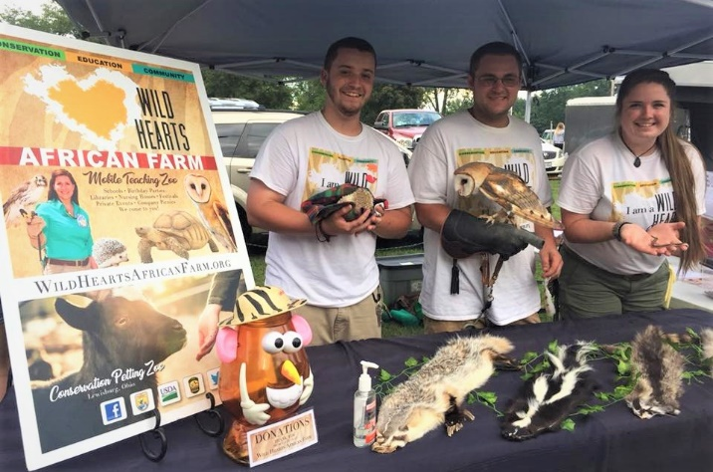
Show your pride of being a "Wild Heart"!
Upon acceptance of an internship you must
purchase a Wild Heart shirt.
A mask will also be provided for you.
Wild Heart shirts are $20 and you are required
to wear it at all educational programs or zoo events.

Instructions: Please select the shirt size below
so it can be ordered for you.
Money is due on your first day.

Name __________________________ Date _________

Size: Mens- S M L XL 2X Ladies- S M L XL

(Office use) Money received ___________

