This Wild Hearts Animal Husbandry Internship Position
is a hands-on, un-paid, voluntary agritourism and zoology learning opportunity
allowing those interested in animal care careers to gain
experience working with animals in a zoo and farm setting.

REQUIREMENTS: This program lasts for a minimum of 250 hours, and may include 3-5 shifts per week for a minimum of 10 weeks, but 12-16 weeks is encouraged. Many interns choose to complete more than 250 hours for college requirements or extra experience. Animal husbandry chores, onsite tours and offsite Mobile Teaching Zoo Programs occur during afternoons, weekends, holidays and evenings. Applicant must commit to a schedule and be on-time. This voluntary position requires working inside and outside in all weather conditions with a variety of animals, strenuous lifting, cleaning, shoveling, mulching, weeding, following instructions and mental alertness, and most importantly a positive attitude and eagerness to learn. Applicants must be at least 18-years-old. You must possess a valid driver’s license and have a reliable vehicle as public transportation is not available at our location.

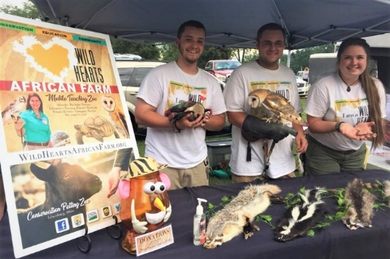

Email this completed application and attachments in ONE EMAIL to amanda@wildheartsafricanfarm.org

Please label your file names with your last name.
Attach a cover letter, resume, and two letters of recommendation OR references we may contact.

It is the policy of this organization to provide equal opportunities without regard
to race, color, religion, national origin, gender, sexual preference, age, or disability.
Thank you for completing this application form and for your interest in interning with us.

Applications are accepted year-round, however spaces fill quickly for summer.

Thank You & Stay Wild!

APPLICATION FOR VOLUNTEER INTERNSHIP PROGRAM
Name and Preferred Pronouns: Click or tap here to enter text. Date of Birth: Driver’s License #
Address: Click or tap here to enter text.
Cell Phone: Click or tap here to enter text. Email: Click or tap here to enter text.
College: Click or tap here to enter text. Major: Expected Graduation Date:
Current Employer Name Address & Phone: Click or tap here to enter text.
Available Internship Dates: Click or tap to enter a date. To Click or tap to enter a date.
We typically start at 8-9am and you will work a 6+ hour shift. Evening Shifts may be available.
Adjustments to shifts to accommodate your school or work schedules may be made if requested.
Monday Choose an item. Tuesday Choose an item. Wednesday Choose an item. Thursday Choose an item. Friday Choose an item. Saturday Choose an item. Sunday Choose an item.

Summarize special skills and qualifications you have acquired from employment, previous volunteer work, or through other activities, including hobbies or sports.
Click or tap here to enter text.
Do you have any vacations or time-off requests during your internship period? Please disclose all dates here.
Click or tap here to enter text.
Tell us why you want to be a "Wild Hearts Intern". Will this be for class credit?
Click or tap here to enter text.
If chosen, tell us how you plan to COMMIT yourself to get the most from this opportunity.
Click or tap here to enter text.
What is your favorite animal, why and how do you hope to impact conservation for that species?
Click or tap here to enter text.

Emergency Contact:
Name Click or tap here to enter text. Phone Numbers Click or tap here to enter text. Email Address Click or tap here to enter text.

Click or tap here to enter text. I understand that Wild Hearts does not provide housing, transportation or fuel stipends, and that I am responsible for researching and acquiring housing and transportation. By applying for this internship I acknowledge that have sufficient resources and time to commit to the position requirements. Please tell us your housing plans in your cover letter if applicable.

Click or tap here to enter text. I have received, read, understood, agreed to and will comply with the Volunteer/ Waiver and Volunteer Guidelines and Requirements. I will purchase and wear a staff shirt ($10) to all programs. I understand that vacation requests and days off may not be accommodated during this short internship duration. Unexcused absences and tardiness may be grounds for termination. I understand this is a volunteer, un-paid learning experience and will not receive any compensation.
Instructions: Please select the shirt size below so it can be ordered for you. Money is due on your first day.

Size: Choose an item.
Click or tap here to enter text. Resume, cover letter and two letters of recommendation or references are included.

By submitting this application, I affirm that the facts set forth in it are true and complete. I understand that if I am accepted as an intern, any false statements, omissions, or other misrepresentations made by me on this application may result in my immediate dismissal.

Digital Signature: Click or tap here to enter text. Date: Click or tap here to enter text.

